- Launch one EC2 using Amazon Linux 2 image and add a script in user data to install Apache.
Objective: This is to elaborate how to launch an Amazon EC2 instance using the Amazon Linux AMI and automatically install the Apache web server using a User Data script or bootstrap
Steps to launch EC2 using amazon linux with httpd bootstrap:
- Launch https://aws.amazon.com/ on browser.
- Sign in as a root user with the email address and password.
- Search for ec2 service.
- Click on launch instance.
- Give any name to the instance.
- Under AMI section, select quick start option
- Select amazon linux as OS.
- Amazon linux 2023
- Select t3.micro instance type.
- Select a key pair or create new key pair if not available.
- Select create security group under network settings.
- Enter security group name and give any description.
- Click on add security group rule.
- Select type:ssh, protocol:TCP, port:22 and source type: anywhere
- Navigate to advanced details section
- Add a bash script to run httpd under user data section(bootstrap)
- Lastly click on launch instance.
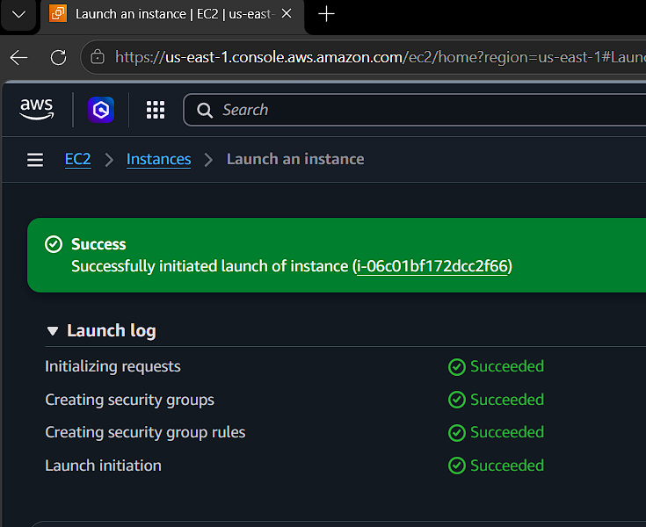
- Navigate to instance page.
- Open git bash from the location where the keys.pem is downloaded.
- Connect to the server using ssh -i keys.pem ec2-user@<public IP address>
- Enter sudo systemctl status httpd
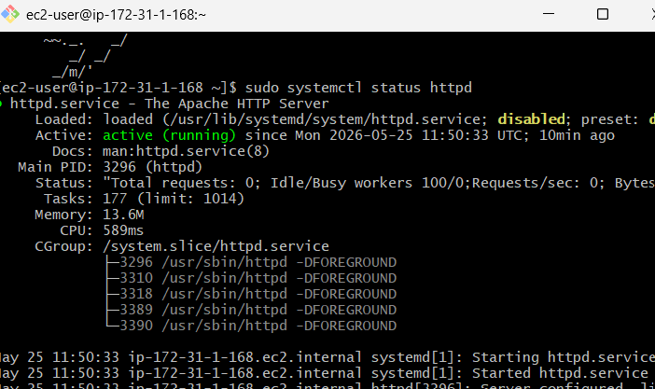
- Notice that the httpd service is actively running.
- Navigate to browser and enter public ip address from instance.
- Observe that the page fails to load.
- Now navigate to inbound rules under security groups.
- Click on add rule.
- Select custom tcp, port range is 80 and source as anywhere.
- Click on save rules.
- Now go back to browser and enter public ip address.
- Observe that httpd static deployment page is loaded.
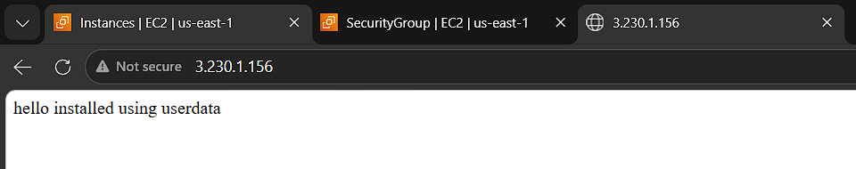
- Launch one EC2 using Ubuntu image and add a script in user data to install Nginx.
Objective: This is to elaborate how to launch an Amazon EC2 instance using the ubuntu AMI and automatically install the nginx web server using a User Data script or bootstrap
Steps to launch EC2 using ubuntu with nginx bootstrap:
- Launch https://aws.amazon.com/ on browser.
- Sign in as a root user with the email address and password.
- Search for ec2 service.
- Click on launch instance.
- Give any name to the instance.
- Under AMI section, select quick start option
- Select ubuntu as OS.
- Ubuntu server 26.04 lts
- Select t3.micro instance type.
- Select a key pair or create new key pair if not available.
- Select create security group under network settings.
- Enter security group name and give any description.
- Click on add security group rule.
- Select type:ssh, protocol:TCP, port:22 and source type: anywhere
- Navigate to advanced details section
- Add a bash script to run nginx under user data section(bootstrap)
- Lastly click on launch instance.
- Navigate to instance page.
- Open git bash from the location where the keys.pem is downloaded.
- Connect to the server using ssh -i keys.pem ubuntu@<public IP address>
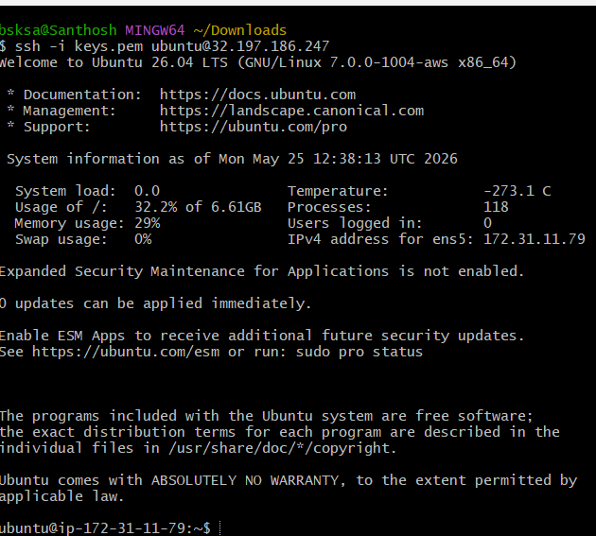
- Enter sudo systemctl status nginx
- Notice that the nginx service is actively running.
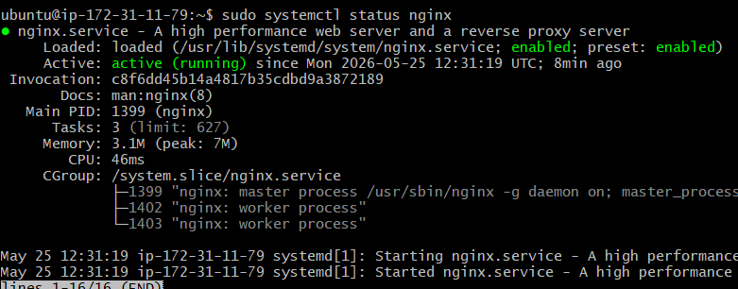
- Navigate to browser and enter public ip address from instance.
- Observe that the page fails to load.
- Now navigate to inbound rules under security groups.
- Click on add rule.
- Select custom tcp, port range is 80 and source as anywhere.
- Click on save rules.
- Now go back to browser and enter public ip address.
- Observe that httpd static deployment page is loaded.
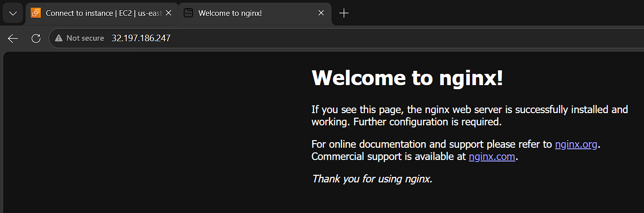

- Launch one Windows server and install Tomcat on Windows.
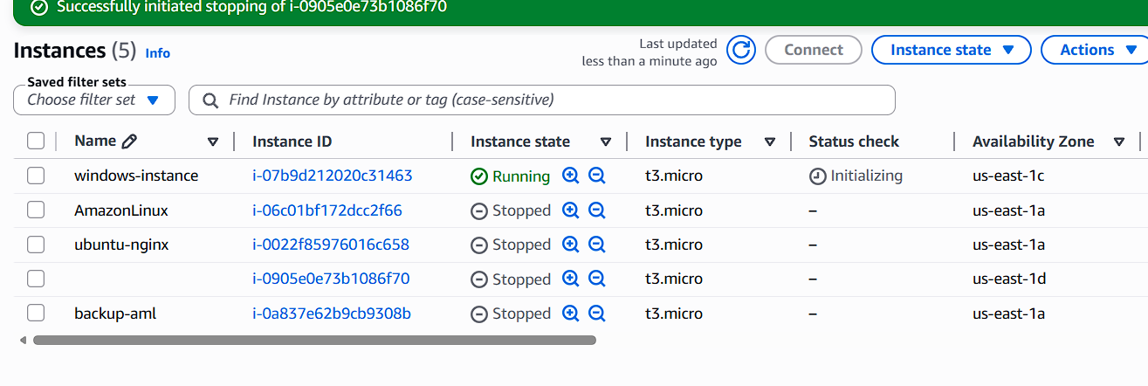

- Take a snapshot of the instance created in Task 1.
- Select the instance to take backup in instance page.
- Click on actions.
- Hover the cursor to image and templates.
- Click on image.
- Enter image name as AmazonLinux-backup.
- Enter description and scroll the page down.
- Click on create image.
- Notice that currently creating AMI image name of particular instance pop up is displayed.
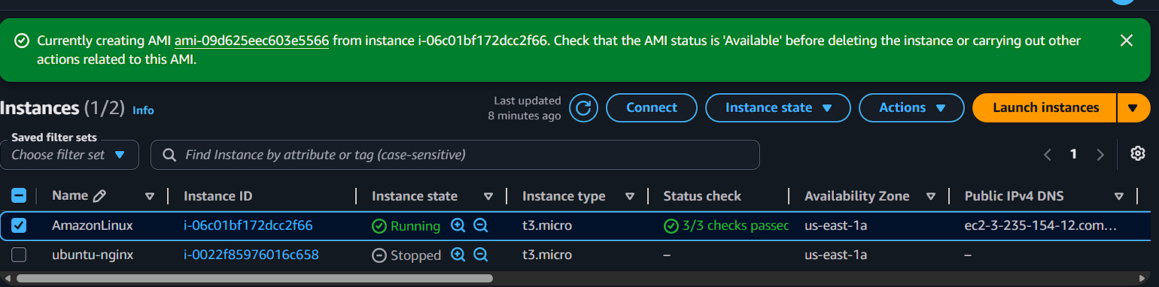
Select ami istance id from the pop up.
Select the check box of the instance and click on launch instance from AMI.
Enter the name for the ami instance.
Under application and OS Images (Amazon Machine Image) select “My AMIs”
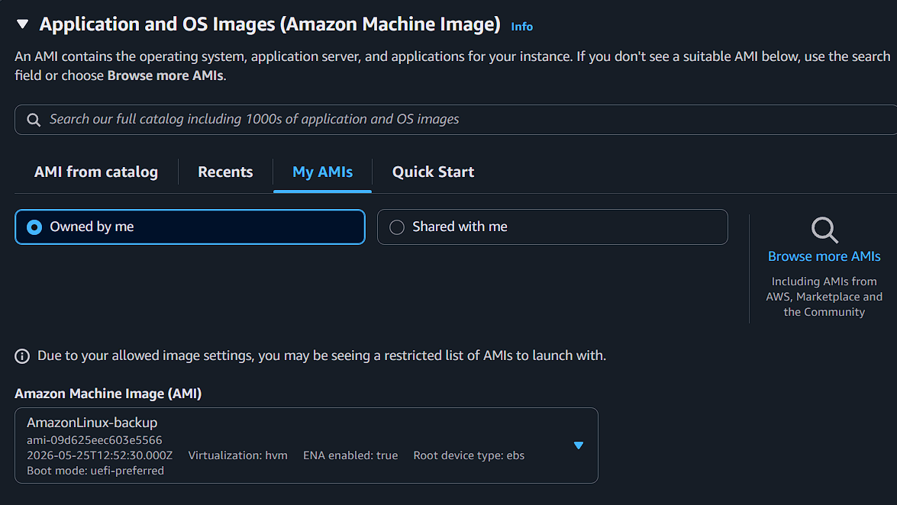
Create backup.pem as key pair.
Launch instance.
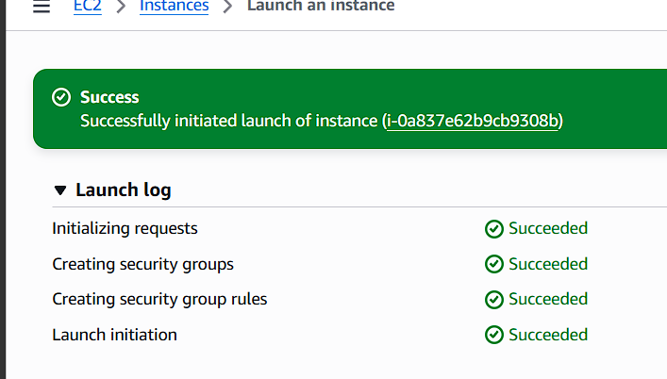
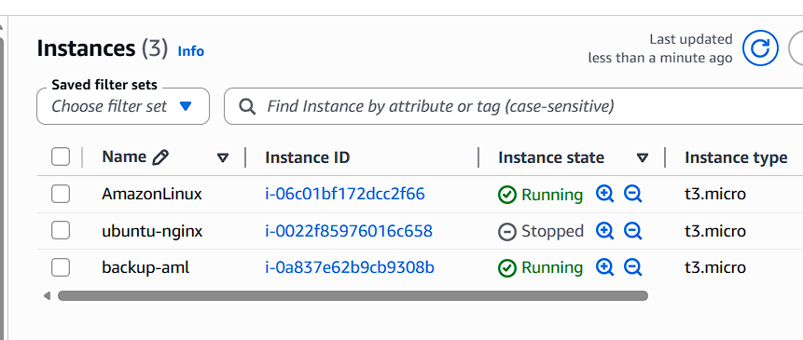
- Assign passwordless authentication for the EC2 created in Task 2.
- Open gitbash on your local machine
- Generate key using ssh-keygen
- Copy the generated key from the specific rsa_id.pub file
- Navigate to EC2 instance connect ubuntu terminal
- Change the directly to ~/.ssh
- Create a file vi authorized_keys
- Paste the copied rsa_id.pub key
- Change the file permission to chmod 600
- Again switch to gitbash
- Connect to EC2 instance using ssh ubuntu@<public ip>
- Notice that user is connected to the instance directly without any pem key or password authentication.
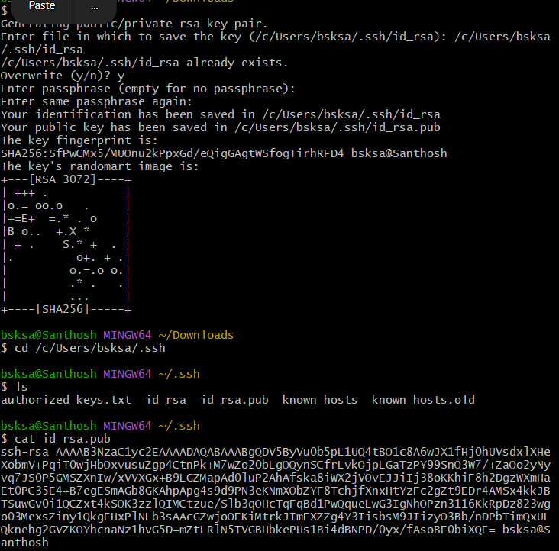
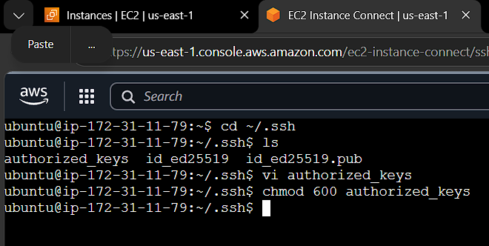
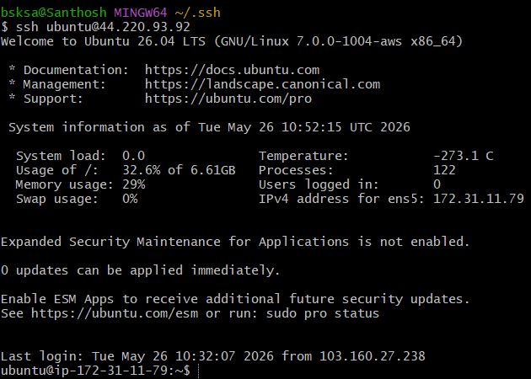
- Launch any EC2 using the spot purchasing option.
- Launch https://aws.amazon.com/ on browser.
- Sign in as a root user with the email address and password.
- Search for ec2 service.
- Click on launch instance.
- Give any name to the instance.
- Under AMI section, select quick start option
- Select ubuntu as OS.
- Ubuntu server 26.04 lts
- Select t3.micro instance type.
- Select a key pair or create new key pair if not available.
- Select create security group under network settings.
- Enter security group name and give any description.
- Click on add security group rule.
- Select type:ssh, protocol:TCP, port:22 and source type: anywhere
- Navigate to advanced details section.
- Navigate to purchasing option section.
- Select spot instances option.
- Click on launch instance.
- Navigate to instance page
- Notice that the spot-instance is running.
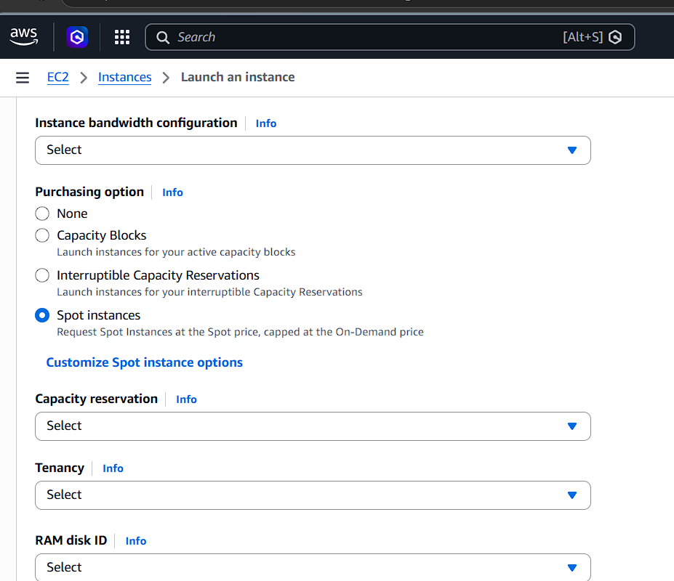
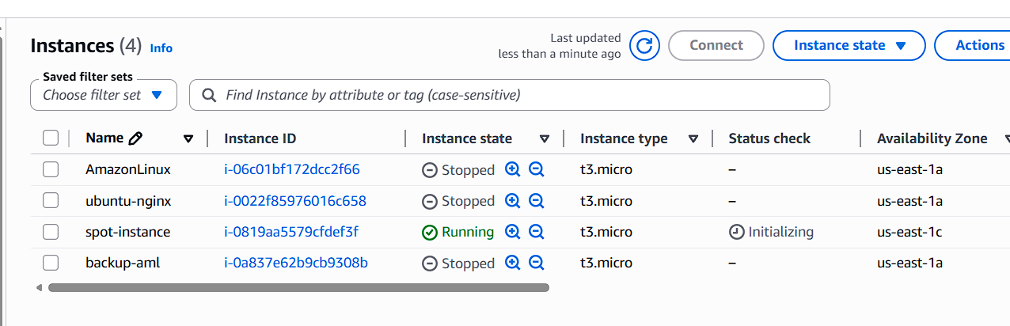

- Enable termination policy on the EC2 created in Task 2.
- Select ubuntu-nginx instance from instance page.
- Click on actions button.
- Select instance settings.
- Click on change termination protection.
- Notice that the change protection popup is displayed.
- Select the check box to enable termination protection.
- Click on save button.
- Navigate to ubuntu-nginx instance page.
- Scroll down to details section.
- Observe that termination protection is enabled.
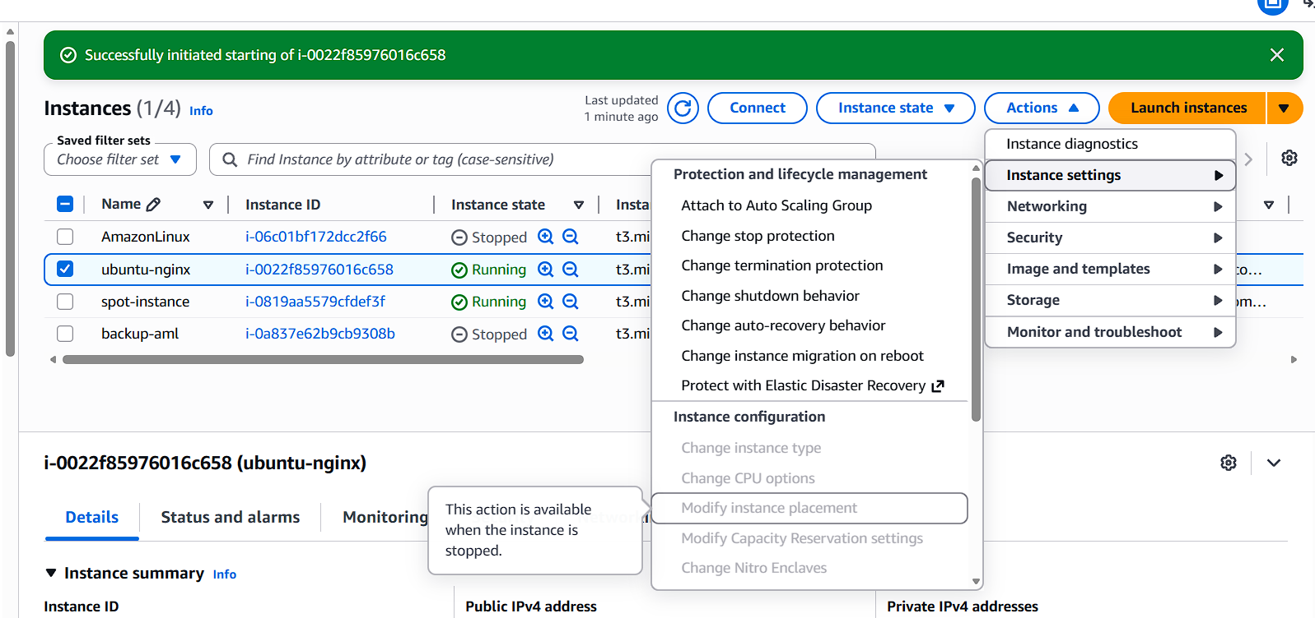
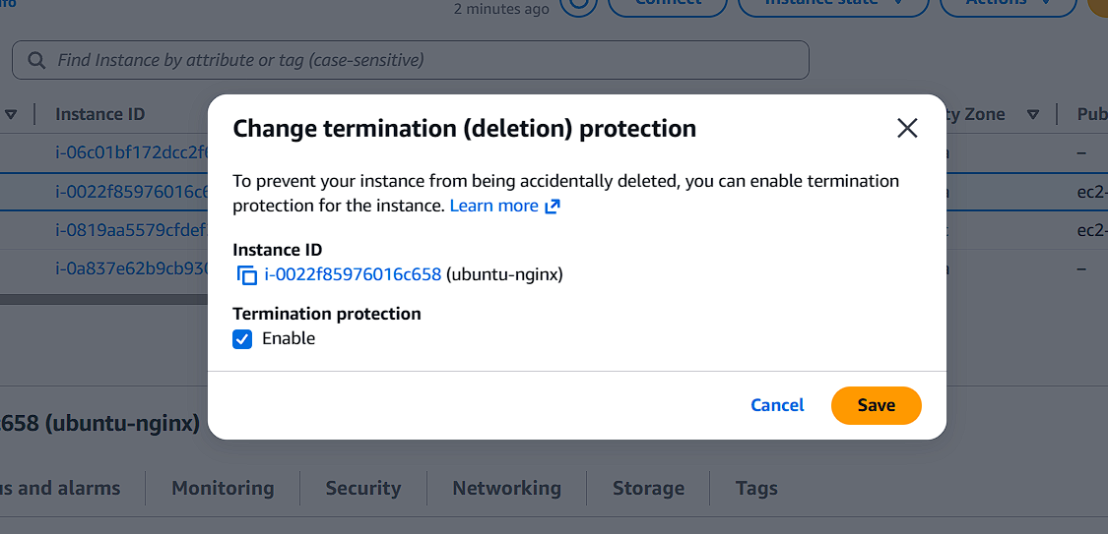
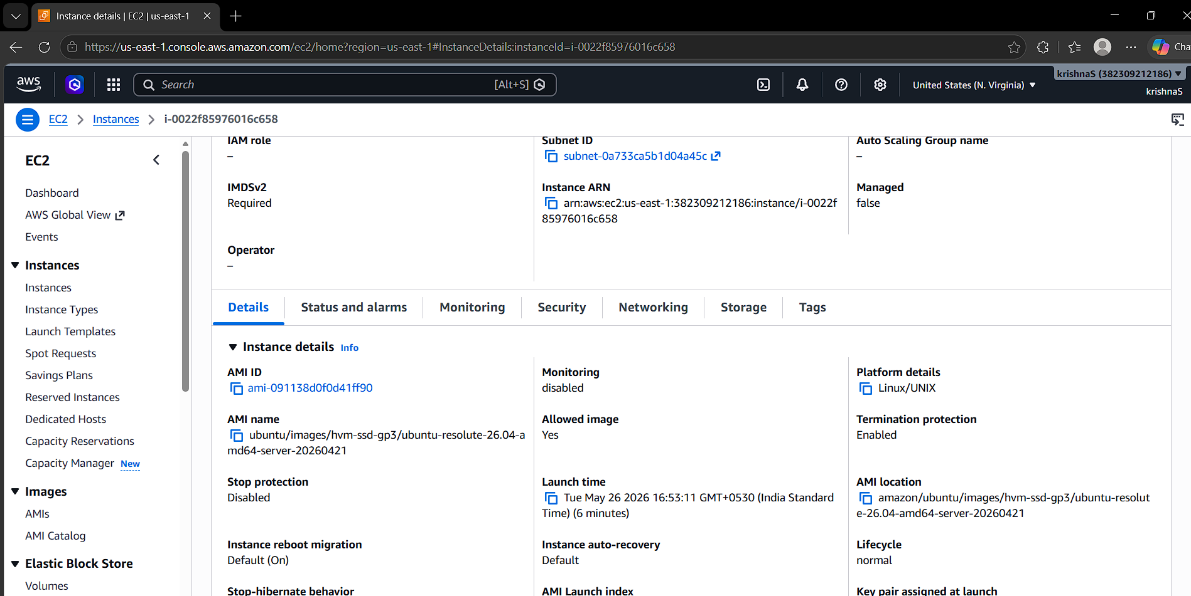
- Launch one EC2 using AWS CLI.
- Launch https://aws.amazon.com/ on browser.
- Sign in as a root user with the email address and password.
- Search for IAM in search bar.
- Select IAM.
- Click on IAM users under access management.
- Click on create user.
- User name is listed under IAM users list page.
- Select the created user.
- Click on create access key.
- Select CLI as usecase.
- Click next
- Click on create access key.
- Notice that the access key is created and user is navigated to retrieve access key page.
- Now open git bash on your local machine.
- Aws - - version to check the aws version.
- Mention aws configure command.
- Enter access key and secret key, location: us-east-1 and output format: json.
- aws ec2 describe-security-groups
- "GroupId": " sg-0abd93266585aa027"
- Launch ec2 instance using
- aws ec2 run-instances \
- --image-id ami-091138d0f0d41ff90 \
- --count 1 \
- --instance-type t3.micro \
- --key-name keys \
- --security-group-ids sg-0abd93266585aa027 \
- --subnet-id subnet-6e7f829e
- aws ec2 describe-instances --output table
- navigate back aws ec2 instance page.
- Observe that instance is running.
